

**Elementary Enrollment and Student**

**Record Management System**

Submitted to:

**MODESTO C. TARRAZONA**

Submitted by:

**Members Signature Date**

**JOHN FORD C. BULIAG** __________ __________

**KARRY ALMOND R. TAN** __________ __________

**VINCE GRIEGO I. GRATUITO** __________ __________

**RENOR JR. BENITO** __________ __________

**October 2023**

**Elementary Enrollment and Student Record Management System**

**Description:**

­­­­­The Elementary Enrollment and Student Record Management System is a software that is tailored specifically to facilitate an efficient enrollment process for elementary school. The program focuses on the implementation of an easy-to-access interface ensuring seamless access to vital information for not only the students but to the educators, parents, and administrators, enhancing most school operations.

**Key Features:**

* **Flexible Login System**
* 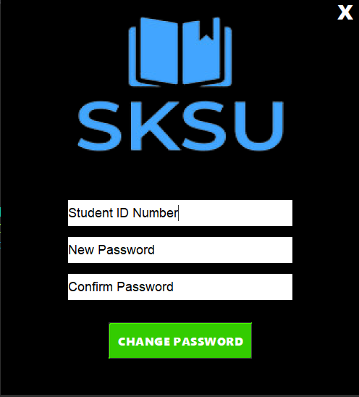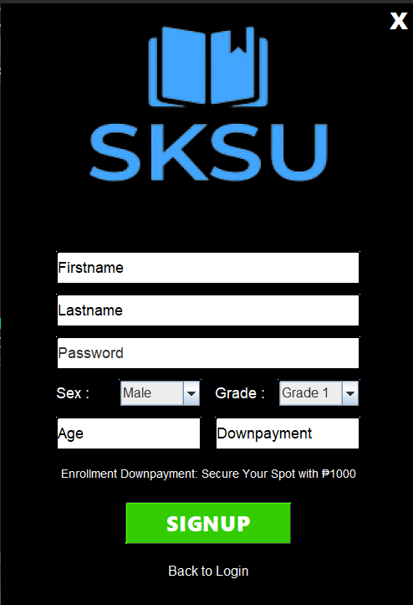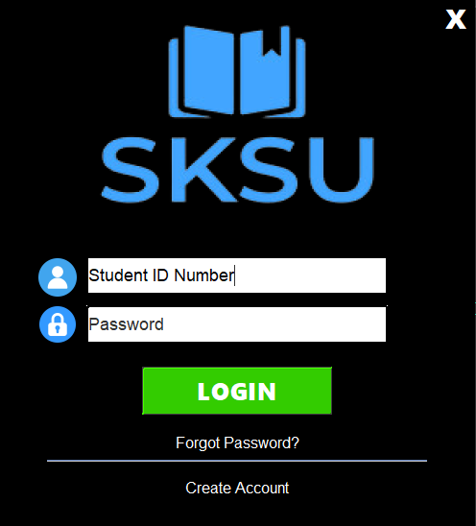Implementing a flexible login system in the project allows users to regain access to their designated accounts even in the event of forgotten passwords. They can utilize their unique ID number to initiate the password reset process and establish a new one. This feature enhances user convenience and ensures account recovery.

* **Efficient Data Access**
* 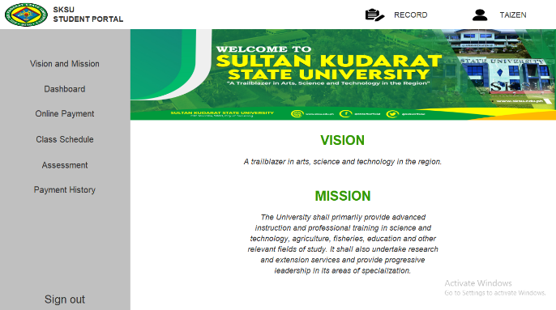The system provides a straightforward interface for the user to interact and navigate throughout their needed information with ease.

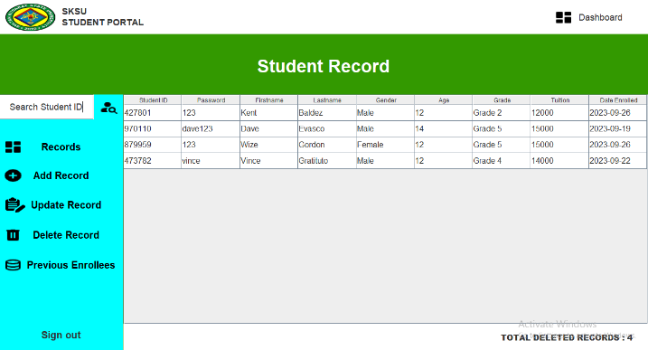

* **Efficient Student Record Manipulation**
* 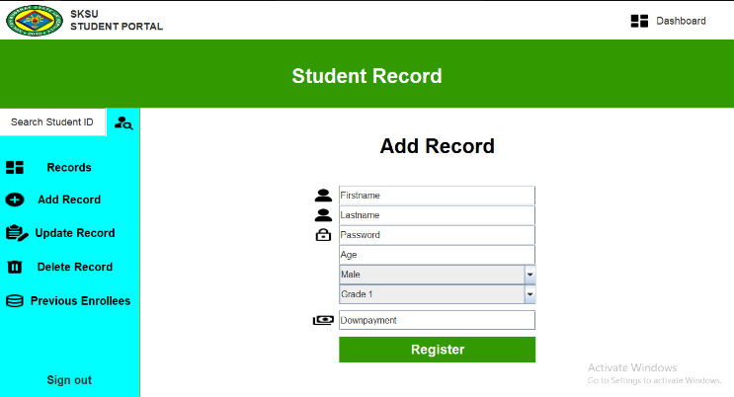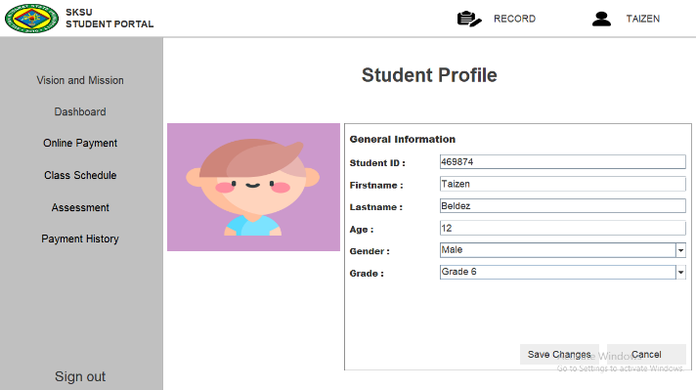As for the administrator from the specified school, they could easily navigate and manipulate student data record or could be able to track an active and inactive account of the student.

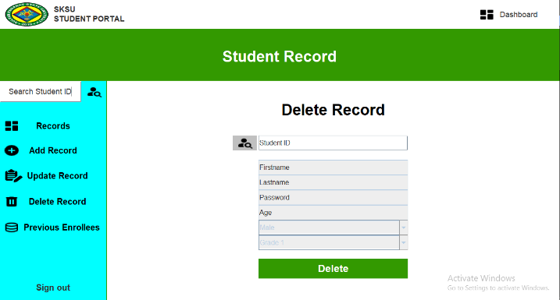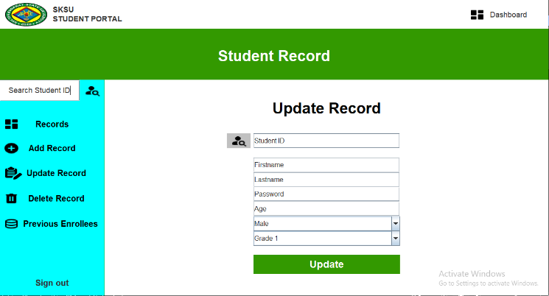

* **Personal Transaction Tracking and Local payment**
* The user can track their transactions within the school using either the hard copy of the specified payment or from their payment history.
* If the user may not be able to directly pay to the school, they could simply decide to make their transaction with the local payment implemented within the system.

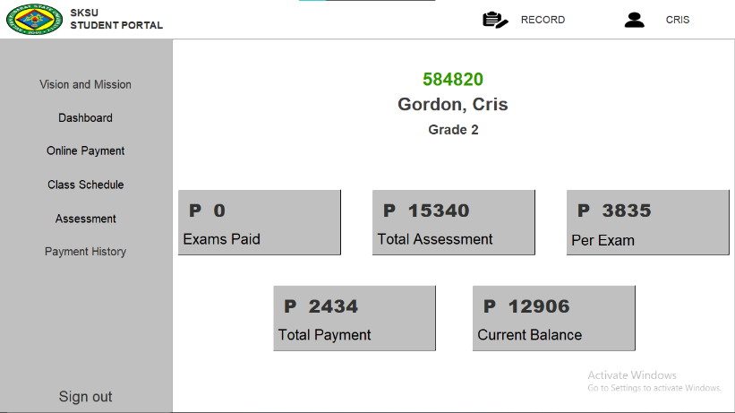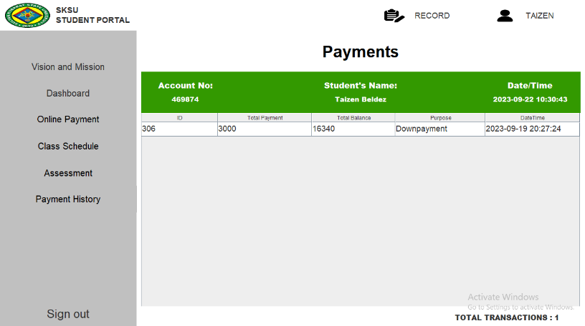

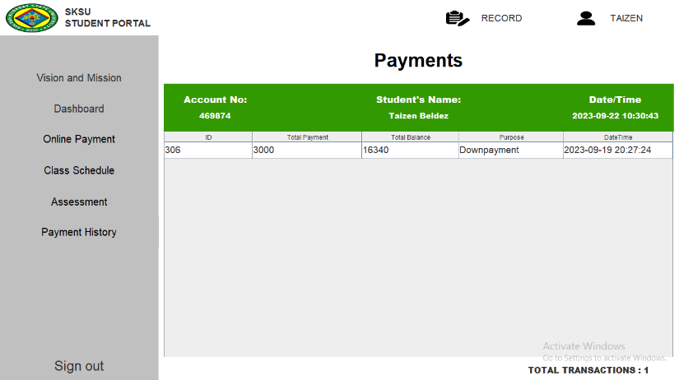

* **Receipt Generation**
* The program enables the user (either requested by the guardians or from the administration) to be provided with their finalized transaction together with their unique reference number formalizing the generation of a receipt.

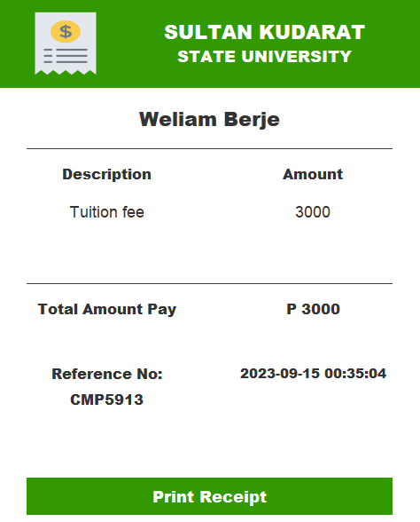

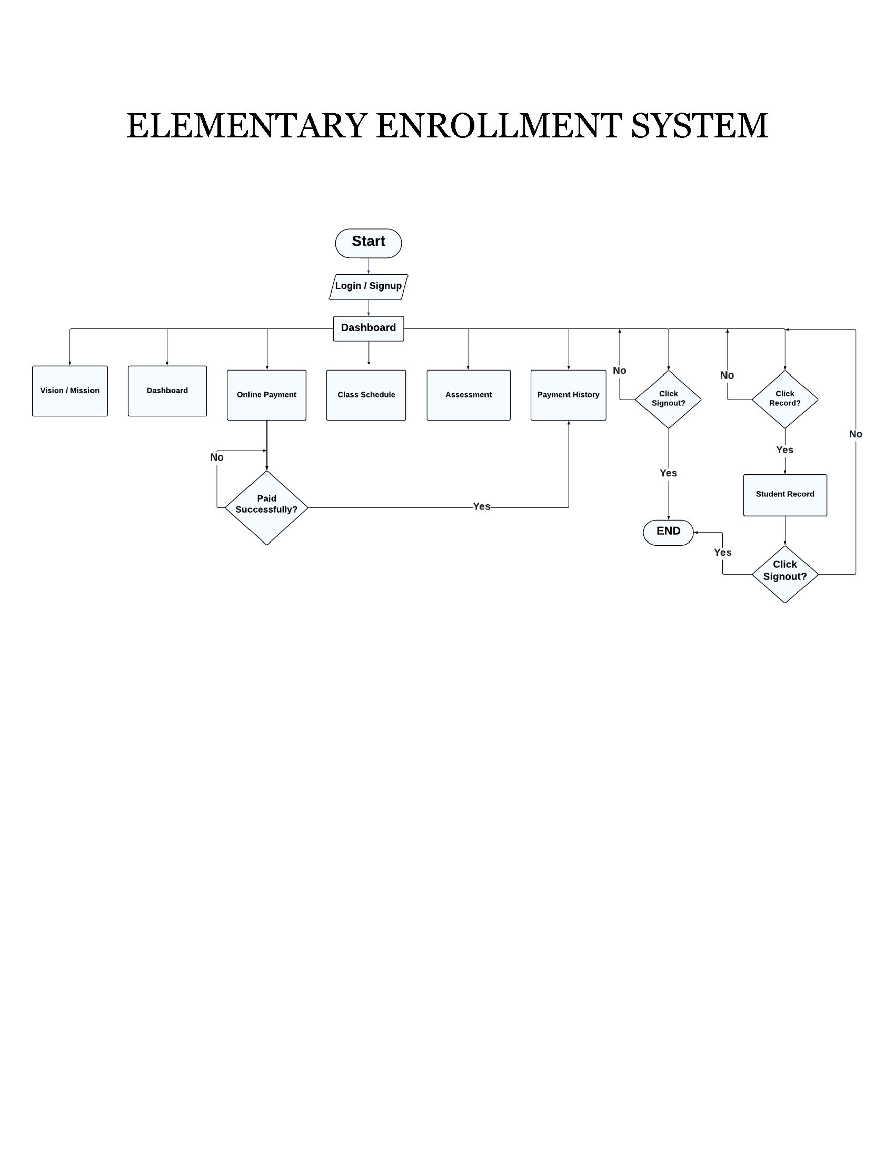

SOURCE CODE

GDRIVE LINK:

https://drive.google.com/drive/folders/1mHJswZRm1JJtXod6Np5-ONUyqUDSPuft?usp=sharing

GITHUB LINK:

https://github.com/ZyroGlitch/Enrollment-System-Database-Manipulation